Ruffling Yarn

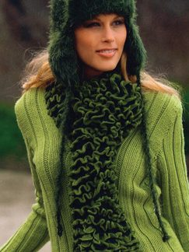
By slipping knitting needles or a crochet hook through the webbing in the tape yarn, you’ll watch it transform into pretty rows of ruffles. The tape is usually a blend of 50% merino wool and 50% synthetic (e.g., acrylic), and it comes in solid colors or variegated.

“Linie 194 Solo” by ONLine – This yarn is distributed by a German company and comes in duotones as shown in the picture on the right.

“Ruffles” yarn by Lion Brand (lionbrand.com) –Do a search for “Ruffles” on the Web site for free patterns, instructions, and instructional videos.

“Tango” yarn by Universal Yarn (universalyarn.com) – Tango comes in eight multi-colored versions, and the Web site shows each color knitted from each of the two sides so you get a feel for the variations (see page 2). The Web site also has free patterns and instructions in pdf format.

“Intermezzo” yarn by Trendsetter Yarns (trendsetteryarns.com) – Intermezzo is a little different from the other three as it has open squares across the top of the yarn. You pull another yarn through every third square, thereby creating the ruffles on one side of the knitted piece. Intermezzo is 81% polyamide, 10% cotton, and 9% acrylic.

Notes about working with ruffling yarn: Knitting all knit or purl stitches creates a reversible piece (i.e., ruffles are on both sides). However, stockinette produces ruffles on one side only. Knitting down the middle of the yarn instead of along the edge produces a nice finish.

With the multi-colored yarns, you can flip the yarn while knitting to get the effect of the other colors (see the Tango pictures on page 2). Flipping the yarn also results in scallops.

It’s better to use a smaller knitting needle as the threads can be a little tight. I had good results with sizes 5, 6, and 7.

I tried a couple methods to the raw ends – rolling them to the wrong side and ignoring them or covering the edges with a sealant. However, I had the best results with turning under the raw edges and hand-stitching a small hem.

Sample of “Solo”
Sample of “Ruffles”
Sample of “Intermezzo”
Sample of “Tango”

Variegated “Tango” yarn by Universal. Purchased from fullthreadahead.com.
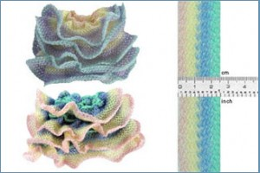
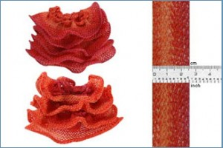
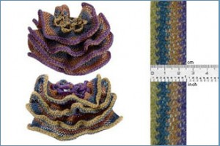
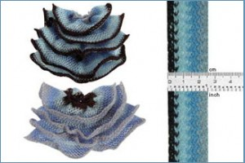
Color 585
Color 581
Color 584
Color 586

